ART CITIES: Salzburg - Liza Lou

05/14/2016

With an emphasis on repetition, formal perfection and materiality, Liza Lou’s sculptures and environments thrive on the tension between the apparent impossibility of their construction, the seductive beauty of their surfaces and the often sinister implications of their subject matter. Over the past several years, while living and working in South Africa, Liza Lou has developed a body of work based upon further ideas of confinement and protection.
By Efi Michalarou
Photo Galerie Thaddaeus Ropac Archive

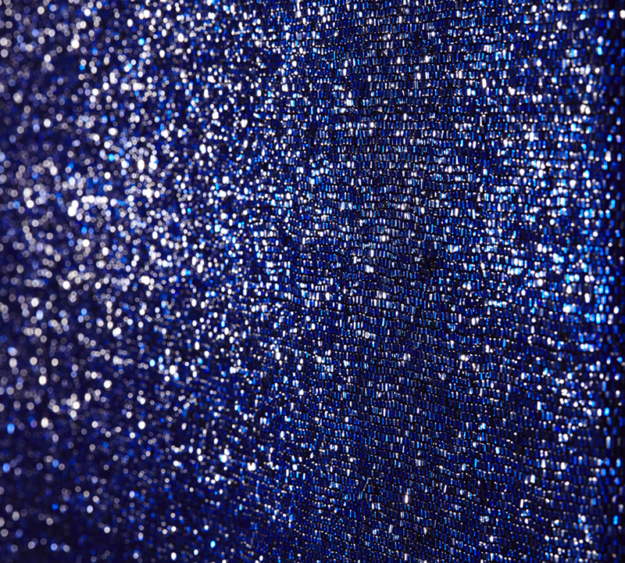
In her solo exhibition at Galerie Thaddaeus Ropac in Salzburg, presents a site specific installation entitled “Waves” and new paintings. Liza Lou uses tiny glass beads as her art medium, completely canvassing entire surfaces and objects in a labyrinth of sparking specks. She expands on conventional interpretation of sculpture and installation by saturating her mock environments in intricately hand-crafted detail. Born in New York, Lou founded a studio collective in 2005 in South Africa, where the traditional craft of beadwork still thrives. Although she does not explicitly use African beading practices in her work, she founded a collective, in 2005, employing Zulu artisans in KwaZulu-Natal, South Africa, who have worked with bead art for generations. The site-specific installation, “The Waves”, spans three ground floor rooms of the gallery. Covering all the walls of each room, hang a grid of white cloths, each scaled to the size of an ordinary dish cloth. Woven from identical materials, to identical sizes, each bears unique marks and blemishes, that like pages in a book, tell the story of their making, unconsciously marked by the sweat and toil of the hands that made them, transforming them into reliquaries of time and human labor. In the exhibition the artist presets also a new series of Blue paintings woven out of glass beads, each in just a single shade of blue. Although an attempt at perfection, the beauty of each picture lies in their small errors, flaws, and subtle variations. Like water, their surfaces reflect and shimmer with the radiance and liquescence of the Indian Ocean, near which they were made.

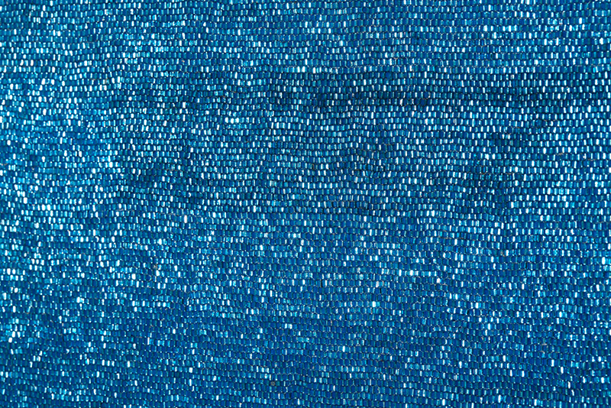

Liza Lou, detail, 2016, © Liza Lou, Photo: Dean Elliot, Courtesy

Galerie Thaddaeus Ropac-Paris/Salzburg

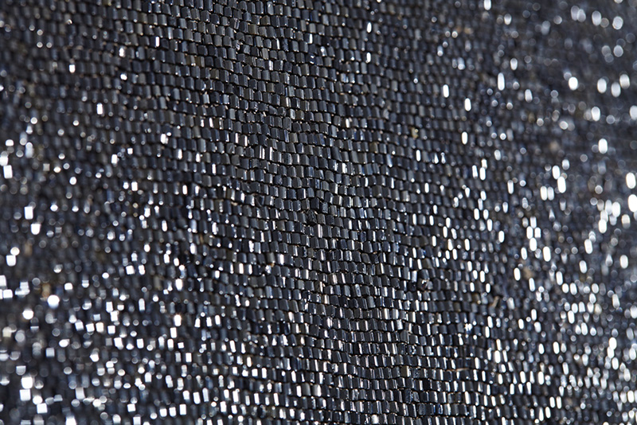

Liza Lou, detail, 2016, © Liza Lou, Photo: Dean Elliot, Courtesy

Galerie Thaddaeus Ropac-Paris/Salzburg

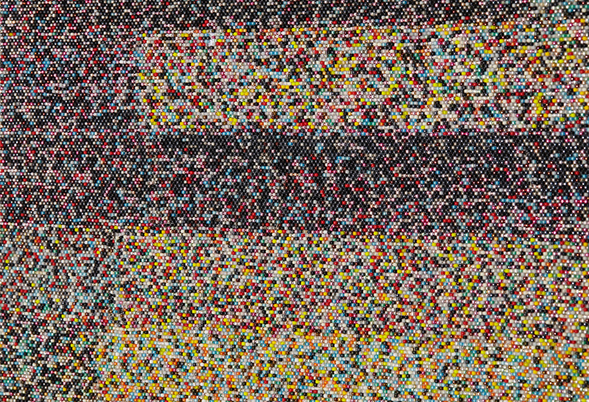

Liza Lou, detail, 2016, © Liza Lou, Photo: Dean Elliot, Courtesy

Galerie Thaddaeus Ropac-Paris/Salzburg

Liza Lou and Team Byron Du Bois, © Liza Lou

Info: Galerie Thaddaeus Ropac, Villa Kast, Mirabellplatz 2, Salzburg, Duration: 14/5-16/7/16, Days & Hours: Tue-Fri 10:00-18:00, Sat 10:00-14:00

